**Interrupts Introduction**

Interrupts are used to handle events that do not happen during the sequential execution of a program. For example, we want to perform certain tasks and these tasks execute sequentially in your program. But there are few tasks that only execute when a special event occurs such as an external trigger signal to the digital input pin of a microcontroller.

An external interrupt or a ‘hardware interrupt’ is caused by the external hardware module. For example, there is a Touch Interrupt which happens when touch is detected, and a GPIO interrupt when a key is pressed down. In this tutorial, we will focus on this type of interrupt.

### How does ISR Routine Work?

With interrupt, we do not need to continuously check the state of the digital input pin. When an interrupt occurs (a change is detected), the processor stops the execution of the main program, and a function is called upon known as ISR or the Interrupt Service Routine. The processor then temporarily works on a different task (ISR) and then gets back to the main program after the handling routine has ended.

This is shown in the figure below.

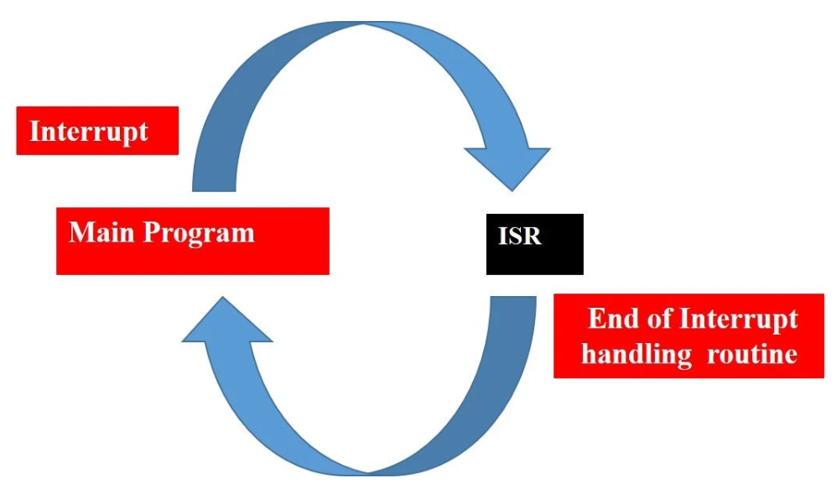

An example can be that of pressing a push button or motion detection with a PIR Sensor. In both cases, a push button or a PIR motion sensor can be used to trigger an interrupt. Therefore, when an external event occurs, the processor stops what it is doing and executes the interrupt service routine which we define for the respective event. After that, it returns to the current program. External Interrupts are extremely useful because with their help we do not have to constantly monitor the digital input pin state.

In summary, the use of external GPIO interrupts makes the embedded system event-driven and responsive. They make use of the microcontroller’s processing time and computing resources efficiently.

## **8051 Interrupt Types**

The 8051 microcontroller can recognize six different types of events. These events can request the microcontroller to temporarily stop the execution of the current program and instead run a special block of code first. The interrupt sources present in 8051 microcontrollers are:

* Reset interrupt
* Timer0 overflow interrupt, TF0
* Timer1 overflow interrupt, TF1
* External hardware interrupt, INT0
* External hardware interrupt, INT1
* Serial communication interrupt, (RI/TI)

The 8051 microcontroller generates the [**timers**](http://microcontrollerslab.com/8051-timer-generate-delay/) and the serial interrupts internally. While the external interrupts are generated via externally interfacing devices or switches that are connected to the microcontroller, these external interrupts can be edge-triggered or level-triggered.

## **8051 microcontroller Interrupt Service**

A fixed memory area is assigned for each interrupt inside the microcontroller. The **Interrupt Vector Table**contains the starting address of the memory location of every interrupt. When an interrupt occurs, the controller transfers the contents of the program counter onto the stack. Then it jumps to the memory location, which is specified by the**Interrupt Vector Table** (IVT). The code written in this memory area by the programmer starts its execution. We refer to this code as an Interrupt Service Routine (ISR) or an interrupt handler on the 8051 microcontroller.

### Interrupts 8051 microcontroller Vector Table

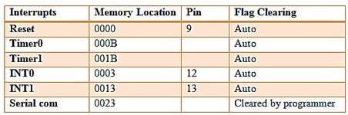

1. **RESET INTERRUPT:**When the reset pin activates, the program execution flow jumps to execute code from the 0000H memory location. Generally, we don’t use this pin. It is also known as power-on reset.
2. **TIMER INTERRUPTS:**Two timers (T0 and T1) are present in the 8051 microcontroller and are responsible for a Timer interrupt. A timer interrupt informs the microcontroller that the corresponding timer has finished counting. Memory locations 000BH and 001BH in the interrupt vector table belong to Timer0 and Timer1, respectively.
3. **EXTERNAL INTERRUPTS:** There are two external interrupts (INT0 and INT1) to serve external devices. Pin numbers 12 and 13 in port 3 are for the external hardware interrupts. Both of these interrupts are active low. An external interrupt informs the microcontroller that an external device needs routine service. Memory locations 0003H and 0013H in the interrupt vector table belong to INT0 and INT1, respectively.
4. **SERIAL INTERRUPT:**This interrupt is useful for serial communication. It has a single interrupt that belongs to both receive and transmit. When enabled, it notifies the controller whether a byte has been received or transmitted. This interrupt vector table assigns location 0023H to this interrupt.

## Interrupt Enable (IE) Register 8051 Microcontroller

**REGISTER CONFIGURATION (for interrupt selection):**Now we have to specify the microcontroller, which interrupts to serve. We can use all of the above interrupts by configuring some bits in a special function register known as the **Interrupt Enabled (IE) register.**These registers enable or disable the various available interrupts.

http://microcontrollerslab.com/wp-content/uploads/2017/02/interrupt-enable-register-in-8051.jpg

| **Interrupt Enabled Register** | **Configuration** |
| --- | --- |
| EA – Enable Interrupt | The EA bit must be set to 1 to enable any of the interrupts. By default, all interrupts are disabled. If EA = 1, it means enable interrupt, and if EA = 0, it means disable Interrupt. |
| ET2 – Timer2 interrupt enable bit | Enable or disable Timer2 overflow or capture interrupts only in 8052. In AT89C51, there are only two timers, so ET2 is not used. |
| ES – Serial port interrupt enable bit | Enable or disable serial port interrupts. |
| ET1 -Timer1 interrupt enable bit | If ET0 = 1, enable the Timer1 overflow interrupt, and if ET0 = 0, disable the Timer1 overflow interrupt. |
| EX1- External interrupt INT1 enable bit | If EX1 = 1, Enable INT1, and if EX1 = 0, Disable INT1. |
| ET0:   Timer0 interrupt enable bit | ET0 = 1, Enable Timer0 overflow interrupt ET0 = 0, Disable Timer0 overflow interrupt. |
| EX1:   External interrupt INT0 enable bit | EX1 = 1, Enable INT0; EX1 = 0, Disable INT0. |

Table 1: Interrupt Enabled Register and its configurations

### Interrupt Service Routine

When we specify an interrupt, the next step is to tell the microcontroller what to do when an interrupt occurs. For this, we write a subroutine or a function for the interrupt, which is interrupt service routine, or ISR. The 8051 microcontroller automatically calls this function when an interrupt occurs. The definition of subroutine must have the **keyword interrupt** with the **interrupt number**. Each interrupt has a specific subroutine number.

#### **External Interrupts of 8051 Microcontroller**

Since we already discussed how to use timers in 8051, in this article we will just talk about how to use external interrupts in 8051. The microcontroller receives the external interrupts from the externally interfaced devices at the INTx pins. These interrupts can be level-triggering or edge-triggering, we can decide this by the TCON register.

* For level-triggering, an interrupt activates for a low signal at the INTx pin.
* For edge-triggering, an interrupt is activates for a high-to-low transition at the INTx pin.

[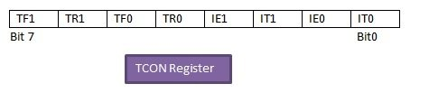](http://microcontrollerslab.com/wp-content/uploads/2017/02/external-interrupt-control-register.jpg)

#### TCON Register

Setting the IT0 and IT1 bits makes the external interrupt 0 and 1 edge-triggered, respectively. By default, these bits are set to 0, so the external interrupt is level-triggered.

**IT1:** External interrupt 1, signal type control bit.

IT1 = 1; // Enable external interrupt 1 to trigger by a falling edge signal.

IT1 = 0; // Enable a low level signal on external interrupt 1 to generate an interrupt.

**IT0:** External interrupt 0, signal type control bit, same as IT1.

IT0 = 1; // Enable external interrupt 0 to trigger by a falling edge signal.

IT0 = 0; // Enable a low level signal on external interrupt 1 to generate an inter

## **How to Configure External Interrupt on 8051 Microcontroller**

1. Enable external interrupt 0 or external interrupt 1 by configuring the IE register. For this, we have to give the command as follows:

IE=0x81; // For INT0

IE=0x84; // For INT1

1. Now we have to write a routine for an external interrupt. For EX0 (INT0), the interrupt number is 0, and for EX1 (INT1), the interrupt number is 1. For using external interrupt INT0, we have to write the routine as follows:

void ISR_ex0(void) interrupt 0

For using external interrupt INT1, we have to write the routine as:

void ISR_ex1(void) interrupt 2

1. For edge-triggering external interrupts, IT0 or IT1 is set to 1.

IT0=1; // For INT0

IT1=1; // For INT1

### ****P****roteus Schematic

In this section, we have provided the Proteus schematic used for simulation. You need to connect the circuit according to this schematic for the code to work.

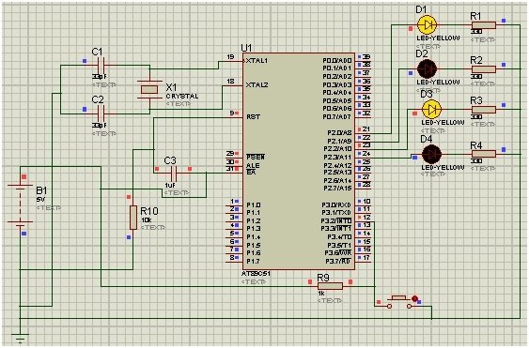

We used the external interrupt INT0 of the 8051 microcontroller. Port 2 is used to monitor the output. In the beginning, we pass the alternate values to the P2 LEDs. When the external interrupt is provided through a push button, the Interrupt service routine starts to execute, and the LED output will toggle for 1 sec. This 1-second delay is given through timer 0 using mode 1.

## 8051 Microcontroller External Interrupts Code

#include<reg51.h>

sbit led1 = P2 ^ 0; // Port 2, Pin 0

sbit led2 = P2 ^ 1; // Port 2, Pin 1

sbit led3 = P2 ^ 2; // Port 2, Pin 2

sbit led4 = P2 ^ 3; // Port 2, Pin 3

void ISR_ex0(void);

void Delay();

void main()

{

P0 = 0x00; // Make all pins zero

P1 = 0x00; // Make all pins zero

P2 = 0x00; // Make all pins zero

P3 = 0x04; // making Port3 pin 2 high

IE = 0x81; // Enable INT0

IT0 = 1; // Set Falling Edge Trigger for INT0

while (1)

{

led1 = 1;

led2 = 0;

led3 = 1;

led4 = 0;

}

}

// Interrupt service routine function

void ISR_ex0(void) interrupt 0 // ISR for external interrupt INT0

{

led1 = ~led1;

led2 = ~led2;

led3 = ~led3;

led4 = ~led4;

Delay();

}

// Initialize delay with timer0

void Delay()

{

int i;

TMOD = 0x01; // Timer0 mode1

for (i = 0; i < 200; i++) {

TH0 = 0xF8; //initial values for 1sec delay

TL0 = 0xCC;

TR0 = 1; // timer0 start

while (TF0 == 0); // check overflow condition

TR0 = 0; // Stop Timer

TF0 = 0; // Clear flag

}

}

### Code Explanation

In this section, we will explain how each part of the code works in detail.

#include<reg51.h>

sbit led1 = P2 ^ 0; // Port 2, Pin 0

sbit led2 = P2 ^ 1; // Port 2, Pin 1

sbit led3 = P2 ^ 2; // Port 2, Pin 2

sbit led4 = P2 ^ 3; // Port 2, Pin 3

void ISR_ex0(void);

void Delay();

In the first line, we add a header < reg51.h>, which helps us deal with the registers of the 8051 microcontroller. Next, we declare 4 pins of Port 2 for LEDs. In the end, we declare two functions: an Interrupt Service Routine and a Delay.

void main()

{

P0 = 0x00; // Make all pins zero

P1 = 0x00; // Make all pins zero

P2 = 0x00; // Make all pins zero

P3 = 0x04; // making Port3 pin 2 high

IE = 0x81; // Enable INT0

IT0 = 1; // Set Falling Edge Trigger for INT0

while (1)

{

led1 = 1;

led2 = 0;

led3 = 1;

led4 = 0;

}

}

In the void main function, we set all the pins of the first 3 Ports to zero, while we set the pins of Port 3, pin 2, to high. Next, we set the Interrupt enable register for INT0 and the interrupt type to edge trigger. In the while loop, we set led1 and led3 as high, whereas led2 and led4 are set as low.

// Interrupt service routine function

void ISR_ex0(void) interrupt 0 // ISR for external interrupt INT0

{

led1 = ~led1;

led2 = ~led2;

led3 = ~led3;

led4 = ~led4;

Delay();

}

Now, we set the ISR function; in this, we have assigned a toggle to the LEDs with a delay. This ISR function will work when an external interrupt is provided to interrupt 0.

// Initialize delay with timer0

void Delay()

{

int i;

TMOD = 0x01; // Timer0 mode1

for (i = 0; i < 200; i++) {

TH0 = 0xF8; //initial values for 1sec delay

TL0 = 0xCC;

TR0 = 1; // timer0 start

while (TF0 == 0); // check overflow condition

TR0 = 0; // Stop Timer

TF0 = 0; // Clear flag

}

}

Lastly, we have the delay function. In this function, we have set the timer mode to 1. Next, we have set the high bit and low bit for a 1-second delay in the for loop. Then we start the timer 0 using TR0 = 1. In the while loop, we check for the overflow condition, which is TF0 == 1, and the delay function ends.

## Conclusion

Here is a summary of the topics we have covered in this article:

* 8051 microcontroller interrupt and its types
* Interrupt service and vector table of the 8051 microcontroller
* Interrupt Enable register and ISR
* step-by-step guide for writing code
* Proteus Schematic
* code and explanation